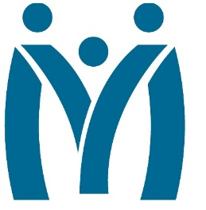

Metropolitan Human Services District
Board of Directors Meeting
December 17, 2021|11:00 AM

3100 General DeGaulle Drive, New Orleans, LA 70114
MHSD fulfills its statutory role as the planning body for the behavioral health, addiction, and intellectual/developmental disability services for the residents of Orleans, Plaquemines and St. Bernard Parishes by ensuring that eligible residents in these parishes have access to person centered and recovery focused supports designed to optimize their role in the community.
Agenda

Call to Order

Attendance

Approval of the November 16, 2021 Minutes

Monitoring Reports

Monthly Dashboard & Telehealth Report

November Dashboard

December Dashboard (Deferred for January meeting)

Fiscal Report:

FY 22 Analysis as of October 31, 2021

FY 22 Analysis as of November 30, 2021 (Deferred for January meeting)

December Reports

Report on Communication between Executive Director and her Executive Team

Annual Report

Monthly Presentation: Division of Advocacy

Decision Information

Consent Agenda

Self-evaluation: Board Performance Review

Adjourn

